Model Development Phase Template

Date | 15 November 2024
Team ID | 739824
Project Title | Fertilizer Recommendation System For Agriculture Using Ai
Maximum Marks | 10 Marks

Initial Model Training Code, Model Validation and Evaluation Report
The initial model training code will be showcased in the future through a screenshot. The model validation and evaluation report will include a summary and training and validation performance metrics for multiple models, presented through respective screenshots.

Initial Model Training Code (5 marks):
Paste the screenshot of the model training code

Model Validation and Evaluation Report (5 marks):
Model | Summary | Training and Validation Performance Metrics
Convolutional Neural Network (CNN) | 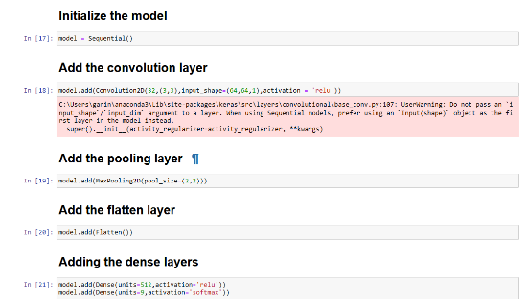 | 